**­­­**

Class 8

**Lecture \***

**Digital Electronics**

**(Logic Gates-II, Boolean algebra)**

**Digital Electronics**



**Lab Objectives:**

* Logic Gates-II.
* Boolean Algebra.

**Logic Gates**

Logic gates are the basic building blocks of any digital system. It is an electronic circuit having one or more than one input and only one output. The relationship between the input and the output is based on a certain logic. Based on this, logic gates are named as AND gate, OR gate, NOT gate etc.

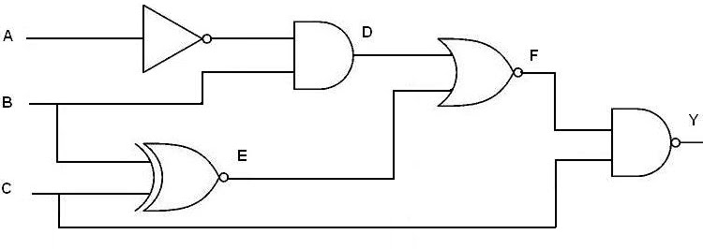

**NOR Gate**

The NOR gate is the complement of the OR gate and uses an OR graphic symbol followed by a small circle.

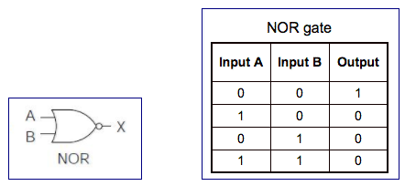

**Exclusive-OR Gate**

The exclusive-OR gate has a graphic symbol similar to the OR gate except for the additional curved line on the input side.

The output of the gate is 1 if any input is 1 but excludes the combination when both inputs are 1. It is similar to an odd function; that is, its output is 1 if an odd number of inputs are 1.

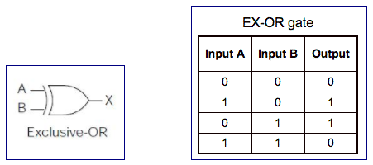

**Exclusive-NOR Gate**

The exclusive-NOR is the complement of the exclusive-OR, as indicated by the small circle in the graphic symbol.

The output of this gate is 1 only if both the inputs are equal to 1 or both inputs are equal to 0.

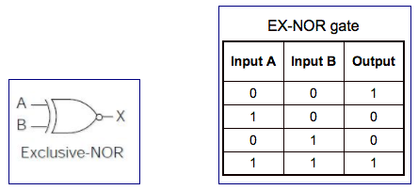

**Boolean algebra**

Boolean algebra is used to analyze and simplify the digital (logic) circuits. It uses only the binary numbers i.e. 0 and 1. It is also called as Binary Algebra or logical Algebra. Boolean algebra was invented by George Boole in 1854.

**Boolean Laws**

There are six types of Boolean Laws.

### Commutative law

Any binary operation which satisfies the following expression is referred to as commutative operation.

Commutative Law

Commutative law states that changing the sequence of the variables does not have any effect on the output of a logic circuit.

### Associative law

This law states that the order in which the logic operations are performed is irrelevant as their effect is the same.

Associative Law

### Distributive law

Distributive law states the following condition.

Distributive Law

### AND law

These laws use the AND operation. Therefore they are called as AND laws.

AND Law

### OR law

These laws use the OR operation. Therefore they are called as OR laws.

OR Law

### INVERSION law

This law uses the NOT operation. The inversion law states that double inversion of a variable results in the original variable itself.

NOT Law